Insch Medical Practice

Dr Stephen J Teale
Dr Kirsten A Cassidy
Dr Karen Simpson
Dr Paul J Davies
Dr Kate Irvine

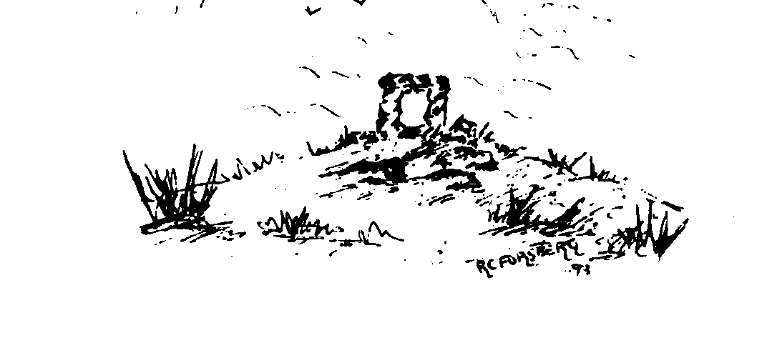

Asthma and COPD, chronic disease monitoring

The way in which we will be monitoring your chronic disease is changing. Moving forward with the Scottish government’s route map out of the COVID pandemic we will still have to maintain the reduced footfall of patients into the Practice.

We will therefore be gathering information from you through online forms using a system called e-consult and carrying out your review by virtual consultation or telephone call.

We appreciate that some patients do not possess the technology to engage in a virtual consultation and if this is the case we will use telephone calls and paper copies of the forms. We would be grateful if you can ensure you confirm to the Practice which technology you have access to when we ask and we can make arrangements accordingly.

If you have a computer, iPad, iPhone, Android phone then the chances are the nurses will successfully be able to complete your virtual consultation. The reception team will be happy to talk you through getting linked up to the Practice. No registration is required and nothing is recorded.

Chronic disease telephone and virtual consultations 

Near Me, is our virtual consultation system. Please do not worry about communicating with us through this system, it is very straightforward to use. You can hold a virtual consultation just like you are sitting in the nurse’s room by using an ipad, PC or iphone. The reception team will send you a link to enter the virtual waiting room with your appointment text or you can log onto at www.inschmedicalpractice.co.uk , go to the appointments tab from the home page and then click the “start video call” button. The system will take you through a test to ensure that your hardware is compatible with the system and, all being well, will put you in the waiting room. Once you are in the waiting room the nurse is alerted and will open a consultation with you. If they are held up, they may message you in the waiting room with an instruction to log back on in 5 mins etc. You can test out entering the waiting room at any time.

If you have an iPhone and require more information on Near Me consultations you can use your phone camera and hover over this bar code and it will give you a link to all the relevant information or click on the link below. You can also request a hardcopy of the information from the Practice.

www.nhsgnearme.scot

